1 Can you find and open the terminal CLI (command line interface) program from the main menu or the taskbar? *(Hint: It is under the Accessories sub-menu)*.

2 The CLI is another way of interacting with the operating system. Opening a command line editor is done using a command at the prompt. There are two editors installed by default, nano and vi. Open nano by typing its name at the prompt followed by the enter key.

|  |
| --- |
| pi@raspberrypi / $ nano |

3 The CLI now shows the editor interface instead of the command prompt, this will be the case until the editor is closed. The main part of the window can be typed in. The bottom of the window shows some commands that can be used with the editor from the keyboard.

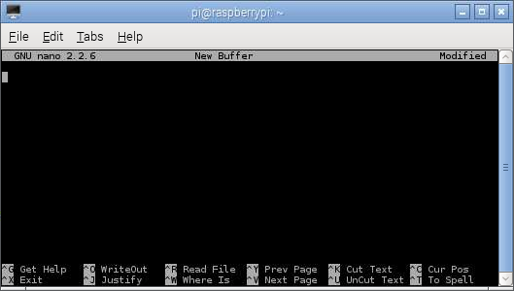

5 To add content to a new file, just begin typing, as you would normally do with a GUI editor.

6 When you are finished typing you would like to save the file. There is no menu bar to click but remember those commands at the bottom of the window, can you see one called WriteOut?

7 WriteOut means that the text you have typed will be written out from the memory buffer you have been typing in, to a file. The command shows in the window as ^O this means that to use this command you should press Ctrl+O (That’s the Ctrl and letter O keys at the same time).

8 You can choose a location and a name for the file (which should use the format yourFileName.txt) then press enter. You should save this in the home directory (~/)

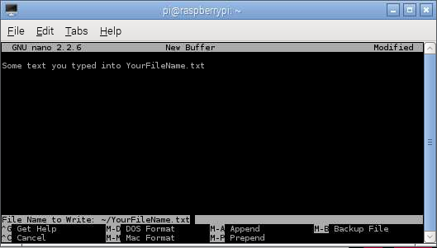

9 To finish, you can use another command from the bottom of the window (^X) to close the editor by pressing Ctrl+X. This should close the editor making the CLI change back to the command prompt.